

Customer Journey Mapping Worksheet

By enabling you to walk a mile in your visitors’ shoes, customer journey maps enable you to to identify key moments that will make or break your visitors’ experiences as they provide you with a customer-centric viewpoint. Connecting with your visitors’ perspective will help you design memorable experiences that not only meet but exceed your visitors’ expectations.
Customer journey mapping helps you become clear on what opportunities exist to communicate with visitors in the most effective and efficient way. This will help you define your messaging and your marketing medium or channel, to get the most from your marketing.
Completing a Customer Journey Map for each of your target markets will help you clarify key problems and questions your visitor will have, identify how you can solve them, and where you can share this information.
Customer journey maps help to:
- Understand your offering from your visitors’ perspective.
- Identify key visitor needs and behaviours.
- Identify opportunities to surprise and delight visitors.
- Identify areas where more understanding is required.

A guest’s journey begins with dreaming about a holiday, then planning and booking it, followed by experiencing it, and sharing about it with family and friends. The following image outlines the process guests go through on this journey.

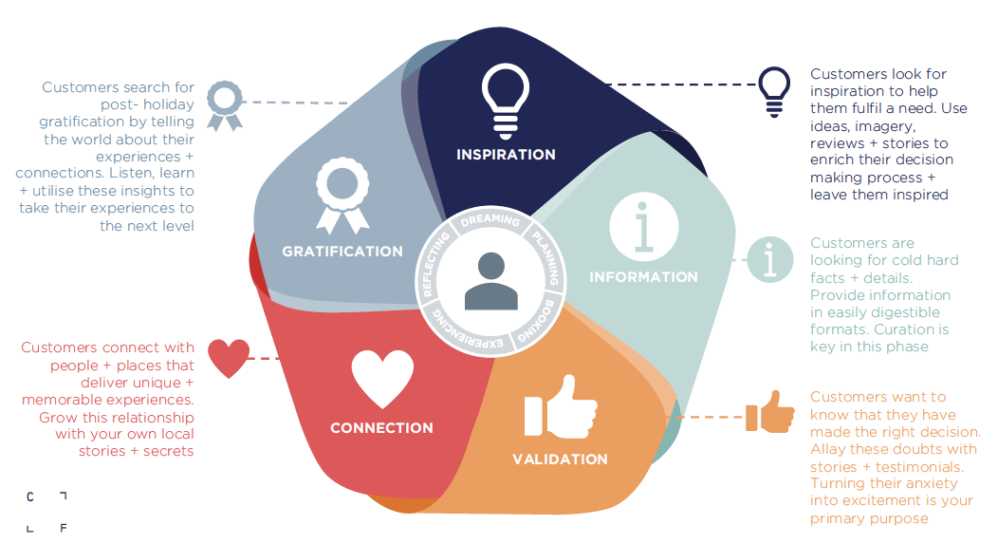

Customer Journey Map

- Capture all the questions, thoughts, and feelings of your visitor for each stage in their journey.
- Capture the action that happens, e.g., your visitor receives a pre-arrival welcome email, a call, or an email to add or change their booking.
- Consider all of the touchpoints the visitor interacts with, e.g., website, social media, email, phone, or brochure.
- Identify the peak visitor moments and how can they be maximised.
- Identify the potential low points and how can they be minimised.

Pre-arrival stages

Stages: | Dreaming | Planning | Booking
Customer actions | - Identify need  - Gather inspiration & ideas  - Consider my options | - Set the parameters  - Research & refine  - Make a decision  - Plan my itinerary | - Shop around  - Book  - Confirm details
What is the customer doing? | - Looking at social media  - Having conversations with others re their trips  - Considering holidays, day trips and family needs  - Checking bank balance  - Collecting and browsing brochures and guides  - Googling  - Narrowing down options by writing pros and cons list  - Looking at travel times to get there & get around | - Researching when, where, how will we make it happen  - Working out family calendar  - Speaking with family and friends that are coming  - Creating to do list  - Refining budget  - Shortlisting options  - Researching weather  - Trawling online for information  - Checking + double checking details, deals to reaffirm decision  - Creating a list of things to do in region  - Looking at deals & packages | - Comparing prices  - Comparing packages across various sites  - Checking reviews to validate information  - Asking peers for tips and deals  - Paying deposits  - Collating booking details and preparing itinerary  - Telling everyone that they are going Making last minute changes to itinerary  - Getting excited and posting countdowns on social media (bragging)
What is the customer thinking? | - Can I afford to go on a holiday?  - What season would be best to go?  - When am I going?  - What’s on my bucket list at this stage of my life? | - Who is looking after the pets when we’re away?  - Where is the best place to stay in our budget?  - Am I making the right decision?  - Who am I going with and how will we get there? | - Is this all going to be worth it in the end?  - Where can I find the best deals?  - What luggage should I take?  - I can’t wait to go!
What is the customer feeling? | - Experiencing FOMO  - Tired and frustrated by life  - Hopeful | - Excited + overwhelmed  - Nervous & anxious  - Trepidation | - Unsure  - Broke  - Doubt
What does the customer need? | INSPIRATION | INFORMATION | VALIDATION
Opportunities for my business in each stage | What stories can you share to connect with your visitors’ interests, values, travel motivations? | What will help visitors plan their trip?  How can you ensure that you stand out from the crowd? | How do you make the booking process easy for visitors?

Experience and post-experience stages

Experience
Pre-Experience | Welcome | Experience | Farewell | Sharing
Prepare for my trip | Go on my trip | Go on my trip | Come home | - Reminisce  - Reflect  - Story telling
- Sorting travel insurance & medication  - Gathering suitable clothing  - Checking luggage & permits  - Making sure everything is going to be ok at home whilst away  - Packing bags | - Travelling + spending on route  - Navigating directions  - Chatting to locals about things not to miss  - Googling other activities on the road – refining trip plan |  | - Travelling home  - Early reminiscing  - Sharing experiences with family & friends  - Unpacking  - Sorting memorabilia | - Reviewing photos  - Writing reviews  - Completing surveys  - Sharing on social media  - Talking to friends, family & colleagues  - Telling stories  - Sharing gifts & souvenirs  - Bragging  - Planning next trip  - Rebooking
- Have I remembered everything? What have I forgotten?  - Do I need to take everything with me, or can we get stuff when we arrive? | - Have I made the right choices?  - I hope this trip lives up to expectations  - I wish I had more time here |  | - That was such a pleasant surprise  - Should we go back soon, or have we seen everything? | - That was a great trip – I can’t wait to tell everyone about it  - I’ve got some great ideas that we can recreate at home  - Where else could we go?
- Excitement  - Guilty | - Relaxed & happy  - Judgemental | - Elation  - Relief | - Post-holiday depression  - Broke  - Elation | - Emotional  - Inspired  - Re-energised  - Sad it’s over  - Happy to be home
CONNECTION |  |  |  | GRATIFICATION
What can you do to ensure that your visitors know what to expect and arrive prepared to have a memorable experience with you?  What stories can you share with visitors’ pre-arrival to ensure they have the best experience with you? | What can you do to help visitors find you and have a positive first impression? | What stories can you share/co-create with visitors whilst they are with you to embed your experience in their memories? | What can you do to ensure your visitors leave inspired and content and ready to share positive stories about your business?  What action do you want your visitors to take as they leave? | How can you curate and share stories that your visitors have created during their time with you?

